 | 

Self-Assessment Report (SAR) for
BAETE Accreditation
Criterion 10
Interactions with the industry
Program: B.Sc. in Information and Communication Engineering
Department of Information and Communication Engineering

Criterion 10: Interactions with the Industry
10.1 Industrial advisory panel:
The Department of Information and Communication Engineering (ICE), DIU, has formed an Industrial Advisory Panel (IAP) to strengthen industry–academia collaboration, to receive strategic guidance on the curriculum and laboratory facilities, and to improve the employability of graduates. The panel consists of professionals from telecommunication, ISP and network operation, software, banking, artificial intelligence and semiconductor (IC design) organizations.
The IAP was first formed in a departmental meeting held on 05 February 2023 with four industry members, and the formation was reported to the Faculty Committee of the Faculty of Engineering on 11 March 2023. The panel was reconstituted with seven members on 08 April 2024 (reported to the Faculty Committee on 20 May 2024) and finalized with ten members in the departmental meeting held on 08 January 2025. The finalized panel was approved in the Faculty Committee meeting held on 21 April 2025 and forwarded to the Honorable Vice Chancellor for approval on 21 July 2025. The list of IAP members is given in Table 10.1 and Appendix 10.1.1.
Table 10.1: Members of the Industrial Advisory Panel (finalized on 08 January 2025)
SL | Name | Designation and Organization
1 | Ohidul Hoque | Circle HR Lead (Rajshahi), Strategic HR Partner, Grameenphone Ltd.
2 | Saleh Uddin Joni | Deputy General Manager, Regional Implementation & Operation, Summit Communications Ltd.
3 | Md. Mahbub Hasan Pavel | Senior Manager (Core Network Administration), Amber IT Ltd.; MikroTik Certified Trainer
4 | Ferdous Alam | CEO, Atova Technology
5 | Md. Sifatullah | Manager, Regional Implementation & Operation, Summit Communications Ltd.
6 | Sadia Shahnewaz | Manager, BRAC Bank PLC
7 | Kazi Mahbubul Alam | Deputy General Manager, Daffodil Online Ltd.
8 | Irad Sakib | System Engineer, Nagad
9 | Md. Hasan Ali | Senior AI Engineer, ACME AI
10 | Rakib Hossain | IC Layout Design, Ulkasemi

The IAP meets with the Department to review the curriculum, laboratory facilities, industrial training and capstone projects. Meetings with the IAP were held on [dates of IAP meetings actually held, from department records]. The meeting notices and attendee lists are attached in Appendix 10.1.2–10.1.3, and the meeting minutes are attached in Appendix 10.1.4.
10.2 Alumni association
The DIU ICE Alumni Association works as the representative body of the alumni of the Department of Information and Communication Engineering and operates under the DIU Alumni Association (DIUAA). Its constitution describes the formation, membership and operating process of the association (Appendix 10.2.1).
The executive committee of the association is formed through election under the DIU Departmental Alumni Association Election 2025–2026. The election process was governed by the following university documents (Appendix 10.2.1):
• Registrar memorandum DIU/Reg./Memo/03/2025/51 dated 09 April 2025 – formation of the Departmental Alumni Association Election Commission, chaired by the Head of the Department, with rules and regulations;
• Registrar memorandum DIU/Reg./Memo/03/2025/120 dated 29 June 2025 – extension of the departmental election deadline to 15 July 2025;
• Memorandum of the Chief Election Commissioner, DIUAA dated 01 July 2025 – inclusion of nominated faculty members in the departmental election commissions;
• Registrar memorandum DIU/Reg/Memo/03/2025/3687-233 dated 29 October 2025 – approval of the Rules and Regulations for the DIU Departmental Alumni Association Election 2025–2026 (Version 2).
A total of 413 votes were cast in the election, and the result was published on the official page of the Department on 29 December 2025. The elected ten-member executive committee, headed by Mr. Ferdosh Alam (President), is given in Appendix 10.2.2. The election result was declared by the Chief Election Commissioner [date of declaration].
The Department communicates with the executive committee through prior notice. The association maintains an election and membership portal, a section on the departmental website, and a Facebook group for communication with alumni and current students; the links are given in Table 10.2 (a). Meeting notices and attendee lists are attached in Appendix 10.2.3–10.2.4, and the meeting minutes are attached in Appendix 10.2.5. Alumni activities are given in Table 10.2 (b).
Table 10.2 (a): Alumni Communication Platform
Platform | Link
DIU Alumni Association | https://alumni.daffodilvarsity.edu.bd/
DIU ICE Alumni Election Portal | https://icealumnidiu.com/
Alumni page, Department of ICE website | [URL of the ICE alumni page]
Social Media (Facebook group: DIU ICE Family, 713 members) | [Facebook group URL]

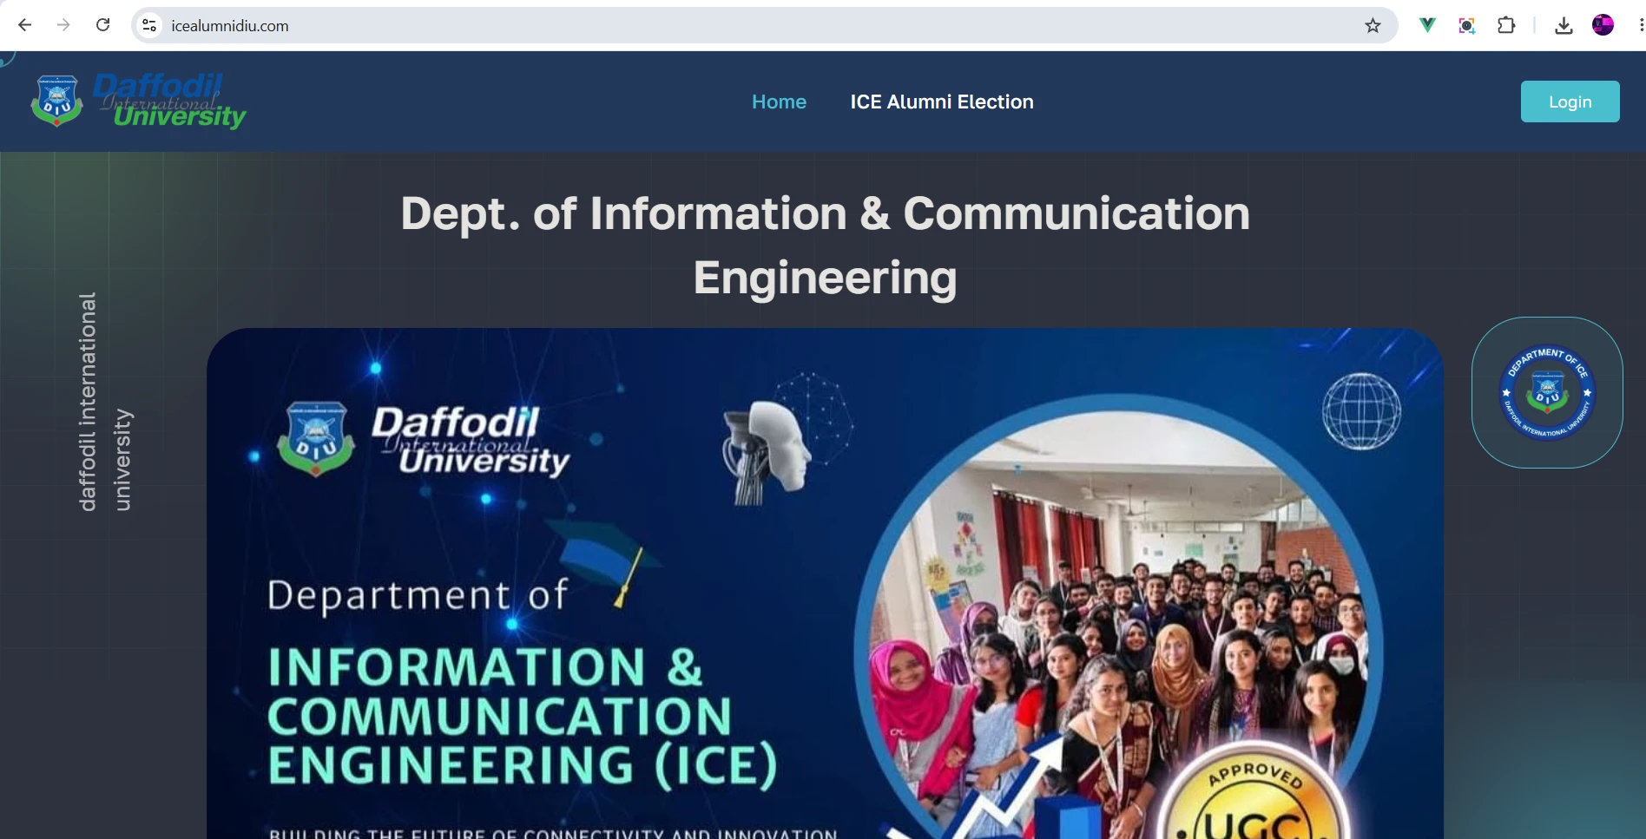
Picture 10.2 (a): DIU ICE Alumni Election Portal
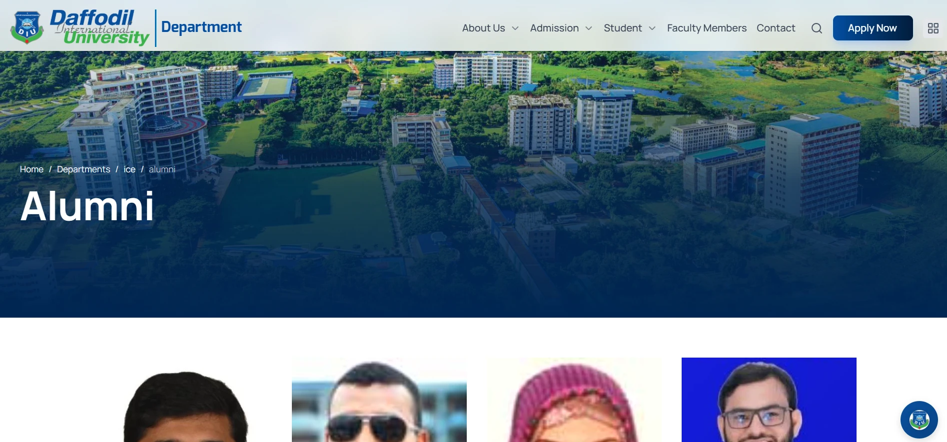
Picture 10.2 (b): Alumni page of the Department of ICE website
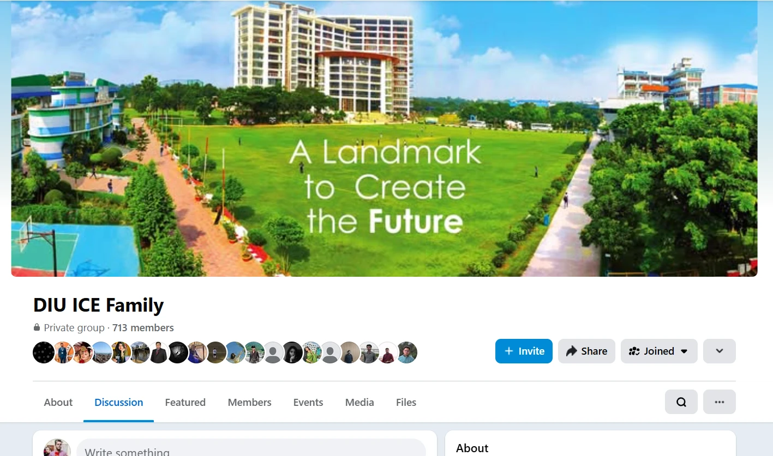
Picture 10.2 (c): Social Media (Facebook group: DIU ICE Family)
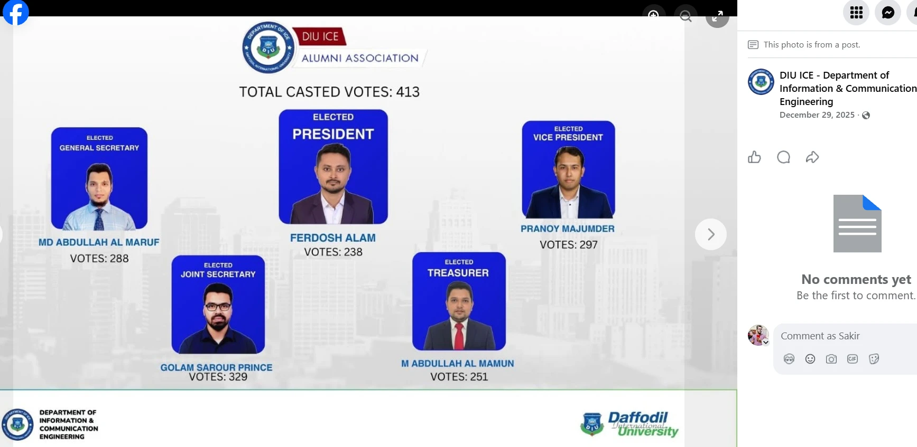
Picture 10.2 (d): Election result published on the official page of the Department (29 December 2025)
Table 10.2 (b): Alumni Activities
SL | Name | Date | Description
1 | Publication of Executive Committee Election Result | 29 Dec 2025 | Result of the DIU ICE Alumni Executive Committee election (413 votes cast) published.
2 | 1st Executive Committee Meeting | 10 Jan 2026 | Held at the Conference Room, Department of ICE, presided by the President.
3 | Executive Committee Meeting (online) | 28 Feb 2026 | Online meeting of the executive committee; membership updates.
4 | ICE Alumni Meetup & Iftar 2026 | 12 Mar 2026 | Alumni gathering to reconnect, share experiences and strengthen the ICE alumni community.
5 | Alumni Association Meeting | 02 May 2026 | Held at the Office of the Head, Department of ICE.

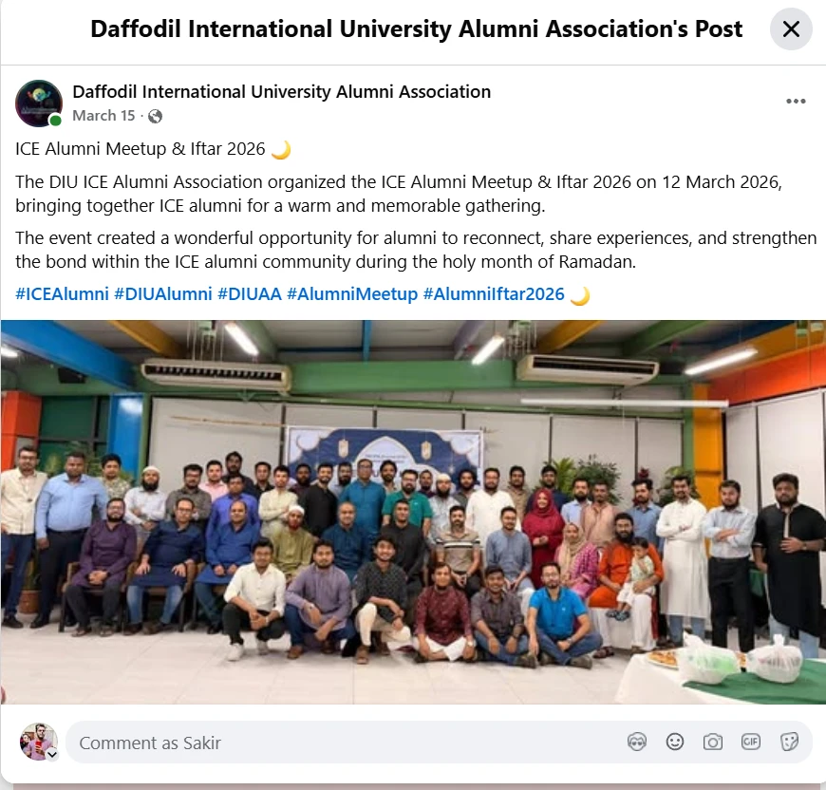
Picture 10.2 (e): ICE Alumni Meetup & Iftar 2026 (12 March 2026)
10.3 Participation of the Industry Experts in academic updates
The Department of ICE ensures industrial participation in the review and improvement of its Program Educational Objectives (PEOs), Program Outcomes (POs) and curriculum through the Industrial Advisory Panel, industry experts in departmental committees, MoU-based collaboration with industry, and industry-led training of students.
a) Industry experts in departmental committees: In the departmental meeting held on 08 January 2025, the Department formed a Syllabus Modification Committee and a Lab Equipment Review Committee. The Lab Equipment Review Committee includes external members from industry – Ferdosh Alam (Founder & CEO, Atova Technology), Md Abdullah Al Maruf (Engineer, AND Telecom Ltd.) and an Assistant General Manager of Live Technologies Ltd. – to review the existing laboratory equipment and recommend improvements in line with industry practice.
b) Industry input in PEO/PO and curriculum review: [Describe how IAP/employer feedback was collected and which curriculum changes resulted, with the approval path and dates. Cite the curriculum review forms, minutes and approvals in Appendix 10.3.]
10.3.1 Events, seminars and workshops led by industry experts
[List seminars, workshops and training sessions conducted by industry experts for ICE students, with dates. Attach posters/photographs in Appendix 10.3.1.]
Table 10.3 (a): Professional development activities with industry
SL | Event Name | Date | Impact
1 | Training on Software Testing (SDLC program), Riseup Labs | Jun–Jul 2024 | Hands-on training on software testing, test-case design and SDLC for ICE students.
2 | [event] | [date] | [impact]

10.3.2 Academic updates
Recommendations from the IAP and industry experts are processed through the following path before they are implemented in the curriculum:
Industry Expert / IAP Recommendation
↓
Discussion in the Departmental Meeting / Syllabus Modification Committee
↓
Approval from the Faculty Committee
↓
Approval from the Academic Council
↓
Implementation in the Departmental Curriculum
Figure 1: Flowchart of updating the academic curriculum.
[Give the curriculum changes made on industry recommendation (course, change, approval dates).]
10.3.3 Industrial collaboration through MoUs
The Department has signed Memoranda of Understanding with industry partners for industrial training, internships, seminars and workshops, joint projects and resource sharing. The MoUs are attached in Appendix 10.3.2.
Table 10.3 (b): MoUs signed between DIU ICE and industries
SL | Name | Signing Date
1 | Atova Technology | 25/08/2021
2 | Amber IT Ltd. | 19/08/2023
3 | Daffodil Online Ltd. | [date – blank on MoU]

10.4 Students' opportunities to gain industrial experience
10.4.1 Internship
Industrial training is part of the degree requirements of the B.Sc. in ICE program through the courses ICE 496 Industrial Training 01 and ICE 498 Industrial Training II. Students undertake training in industry under the supervision of an industry trainer and a departmental supervisor, of [duration as per the approved curriculum]. For example, students completed the "Software Development Life Cycle (SDLC)" industrial attachment program at Riseup Labs from 24 June to 14 July 2024, where industry trainers delivered sessions on requirement gathering, software testing and deployment, and assessed the students through practical tasks (test-case reports and written assessments). Students submit an industrial training report at the end of the training (e.g., report submitted on 27 April 2025).
Student performance is evaluated with a 50-mark Industrial Training/Internship Evaluation Rubric (Appendix 10.4.1.5). Training certificates, assessment tasks and reports are attached in Appendix 10.4.1.1–10.4.1.3. The DIU central memorandum on "Industry Attachment Strategy and Procedure and Formation of Industry Attachment Advisory Cell" (07 March 2023) is given in Appendix 10.4.1.4. [Add placement letters, placement list and evidence of employment in host organizations, if available.]
10.4.2 Final-year design project
The Capstone Project/Thesis is mandatory for the completion of the degree. Students submit a Capstone Project/Thesis/Internship proposal form, which is reviewed by the Capstone Project Committee; approved projects are listed semester-wise with group codes (e.g., SP25001 for Spring 2025). Students present their work in a pre-defence before a board of faculty members, who record remarks for improvement, and in a final defence. Projects are assessed according to the Capstone Project Assessment Pattern (Appendix 10.4.2.3). Proposal forms, pre-defence attendance and the project lists are attached in Appendix 10.4.2.1–10.4.2.4. [Describe industry involvement in topic selection, co-supervision or assessment, with evidence.]
10.4.3 Industry visits
Industry visits are arranged under the industrial training courses to give students first-hand exposure to industrial operations. Faculty members accompany the students, and learning is assessed through individual or group visit reports submitted under ICE 498 Industrial Training II. Visit request letters and visit reports are attached in Appendix 10.4.3.1–10.4.3.2. Industry visits arranged by the Department are given in Table 10.4.
Table 10.4: Industry visits
SL | Organization | Date of Visit | Participants | Evidence
1 | Somoy TV | 24 Jul 2025 | 11 students with faculty members | Request letter (23 Jul 2025)
2 | Walton Hi-Tech Industries PLC | 29 Jul 2025 | ≈60 students and teachers | Request e-mail (24 Jul 2025)
3 | Live Technologies Ltd. | 08 Apr 2026 | ICE 498 students | Visit report
4 | Deepto TV | 16 Apr 2026 | ICE 498 students | Visit report (submitted 29 Apr 2026)

[Add the visit policy, student attendance and photographs (Appendix 10.4.3.3–10.4.3.4).]

